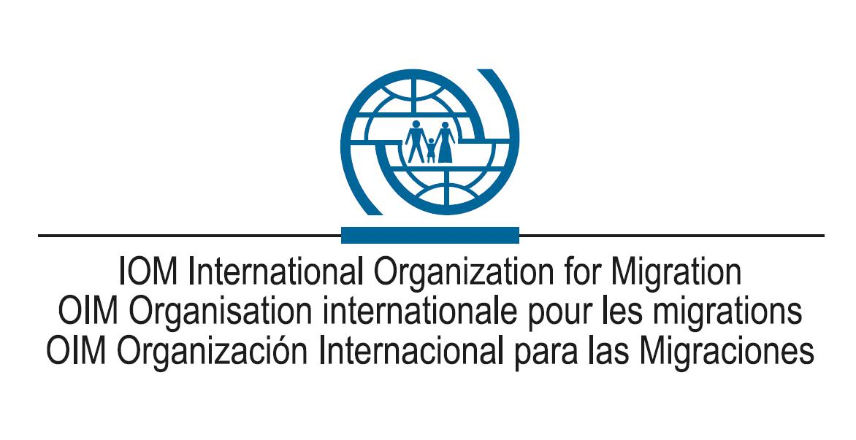
Terms of Reference

I. Position Information
Position title  Position grade  Duty station | Project Assistant  NTA  4 positions: …………………
Seniority band:  Job family:  Organizational unit:  Position number  Position rated ¨  Subject to rotation | Cross Border Return and Reintegration (CBRR) Unit
Reporting directly to | Project Assistant in the region
Overall supervision by | National Programme Officer (CBRR)
Managerial responsibility | No
Directly reporting staff | None

II. Organizational Context and Scope
IOM has been assisting undocumented Afghan returnees from Iran and Pakistan since 2008 in close coordination with government partners.
It has begun implementing a project with the overall aim of strengthening the technical capacity of the Afghan Ministry of Refugees and Repatriation (MoRR) in Information Management as well as in coordinating a reintegration referral mechanism. This forms part of IOM Afghanistan’s long term strategy of transferring the responsibility of assistance for Afghan returnees from neighbouring countries to the Government of the Islamic Republic of Afghanistan (GIRoA).
Under the overall supervision of the National Programme Officer of the Cross Border Return and Reintegration (CBRR) Programme and the direct supervision of Project Assistants in the respected coverage region and HSO, the successful candidate will be responsible for assisting with the implementation of the Technical Capacity Building of Government Partners in Return and Reintegration project.

III. Responsibilities and Accountabilities
- Provide on-site and remote technical support to the users in DORR Provincial Office to maintain the ARIS well-functioning and operational.
- Install and configure computer hardware operating systems, Antivirus and application software.
- Monitor and maintain computer systems, networks and databases for errors, bugs and faults.
- Assist DoRR staff in registering returnees (ARIS data entry) whenever required.
- Assist RIC staff to generate statistical reports of returnee’s reintegration needs from ARIS on monthly basis to be presented in the PRC meetings by head of DoRR.
- Assist RIC staff to record all relevant documents of PRC meeting in ARIS, as well as referral of returnee cases for reintegration support to partners and record of support provided to beneficiaries.
- Assist DoRR organizing PRC meetings, agenda, presentation and its reports.
- Serve as a bridge between IOM technical department and DoRR in escalating technical problems on time and implement solutions.
- Provide class room and on-the-job trainings to DoRR staff on using ARIS, and other applications supported by IOM.
- Set up new users' accounts and profiles and deal with emails configurations.

- Conduct electrical safety checks on computer equipment.

IV. Competencies
The incumbent is expected to demonstrate the following technical and behavioural competencies.
Behavioural
Accountability
- Meets deadline, cost, and quality requirements for outputs
- Takes responsibility for meeting commitments and for any shortcomings
- Monitors own work to correct errors
- Accepts and gives constructive criticism
- Creates a respectful office environment free of harassment and retaliation
- Promotes the prevention of sexual exploitation and abuse (PSEA)

Client Orientation
- Identifies the immediate and peripheral clients of own work
- Establishes and maintains effective working relationships with clients
- Identifies and Monitors changes in the needs of clients, including donors, governments, and project beneficiaries
- Keeps clients informed of developments and setbacks

Continues Learning
- Contributes to colleagues' learning
- Demonstrates interest in improving relevant skills
- Demonstrates interest in acquiring skills relevant to other functional areas
- Keeps abreast of developments in own professional area

Communication
- Actively shares relevant information
- Clearly communicates, and listens to feedback on, changing priorities and procedures
- Writes clearly and effectively, adapting wording and style to the intended audience
- Listens effectively and communicates clearly, adapting delivery to the audience

Creativity & Imitative
  - Actively seeks new ways of improving programmes or services
  - Expands responsibilities while maintaining existing ones
  - Persuades others to consider new ideas
- Proactively develops new ways to resolve problems

Planning and Organizing
  - Sets clear and achievable goals consistent with agreed priorities for self and others
  - Identifies priority activities and assignments for self and others
  - Identifies risks and makes contingency plans
  - Organizes and documents work for planned and unplanned handovers
  - Adjusts priorities and plans to achieve goals
- Allocates appropriate times and resources for own work and that of team members

Professionalism
  - Knowledgeable about and promotes core IOM mandate and migration solutions
  - Identifies issues, opportunities, and risks central to responsibilities
  - Incorporates gender-related needs, perspectives, and concerns, and promotes equal gender participation
  - Treats all colleagues with respect and dignity
- Works effectively with people from different cultures by adapting to relevant cultural contexts

Teamwork
  - Actively contributes to an effective, collegial, and agreeable team environment
  - Contributes to, and follows team objectives
  - Gives credit where credit is due
  - Seeks input and feedback from others
  - Delegates tasks and responsibilities as appropriate
  - Actively supports and implements final group decisions
- Takes joint responsibility for team's work

Technological Awareness
  - Learns about developments in available technology
  - Proactively identifies and advocates for cost-efficient technology solutions
- Understands applicability and limitation of technology and seeks to apply it to appropriate work

Operations
  - Delivers on set objectives in hardship situations
  - Effectively coordinates actions with other implementing partners
  - Works effectively with local authorities, stakeholders, beneficiaries, and the broader community to advance country office or regional objectives

Technical
- 2 to 3 years of experience in a networking environment (LAN/WAN) and first level network/desktop support. Extensive knowledge of Windows, TCP/IP, Telecoms/Network protocols, Cisco devices, VPN, MS Office, Antivirus Software and IT utilities.
- Troubleshooting and resolving first-level and second-level PC hardware and software problems; Large-scale migrations and/or projects in organizations of similar size, scope, and complexity; Local area networks; End-user training and instruction; All versions of the Windows operating system; All MS Office applications; Setup and administration of application and/or Microsoft Windows system servers.
- Working knowledge of Microsoft SQL server, ASP.NET, JavaScript and HTML.

V. Education and Experience
- University degree in computer science or a combination of relevant education and professional experience;
- High school diploma and 5 years of experience in lieu of University degree;
- 3 years’ experience in IT especially configuring Microsoft Windows Server, LAN/WAN, Email server, Troubleshooting, Database Maintenance and administration, and IT support.
- Supplemental courses/technical certificate in information technology or other related field; Supplemental training to keep abreast of changes in information technology; and
- Experience working with specialized international agencies (UN Agencies, International Organizations, and International NGOs) and in complex operations, including conflict and post-conflict situations preferred.

VI. Languages
Required
Fluency in English, Dari and Pashto
Advantageous

